34.119: a) People with normal vision cannot focus on distant objects under water because the image is unable to be focused in a short enough distance to form on the retina. Equivalently, the radius of curvature of the normal eye is about five or six times too great for focusing at the retina to occur.
b) When introducing glasses, let’s first consider what happens at the eye:
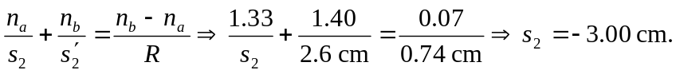That is, the
object for the cornea must be 3.00 cm behind the cornea. Now, assume the glasses are 2.00 cm in front of the eye, then:
This is the focal length in water, but to get it in air, we use the formula from
Problem 34.98: 

